Scott Black  Winger/Forward  2017 Graduate | 3 Mason Drive  North Grafton, MA 01536  555-555-5555  XYZ@gmail.com

OBJECTIVE: To play for an NCAA Division I and contribute my freshmen year.

  High School Varsity started since freshmen year.  INSERT OTHER PERSONAL INFO HERE. | ACADEMICS:  - Overall GPA: 3.4/4.0  - Class Rank: 18/320  - SAT Score:  - ACT Score:  - A.P. Courses:  - Possible college major: Accounting, Psychology  ATHLETICS:  - Height: 6’0”  - Weight: 170 lbs  - Left-footed  - Strength: speed and agility, ball control  - High School Team: Grafton High School  - Coach: John Smith (555) 555-5555  - Club Team: Road Island Reds U19  - Joe Smith (555) 555-5555
SOCCER ACCOMPLISHMENTS:  - All-League MVP (2014, 2015)  - First-Team Worcester League (2015-2016)  - HIS Freshmen Athlete of the Year  - IHS Junior Athlete Year  - San Francisco Cup 2016, Champions  SOCCER STATISTICS:  - 31 Goals and 9 Assists for High School  - 12 Goals and 3 Assists for Club  OTHER ACCOMPLISHMENTS:  - Track Varsity 2014-2016  - 2nd place All State, high jump  - Tennis Varsity 2014-2016  UPCOMING SOCCER TOURNAMENTS:  - Blue Chip Cup, June 4-7  - CASL, May 12-15  - Raleigh, April 27-29 | 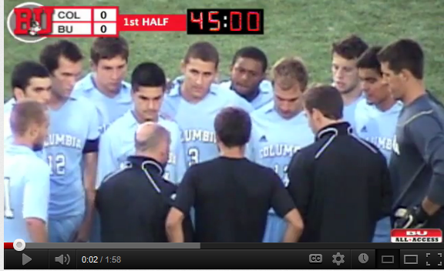  UPLOAD VIDEO TO YOUTUBE. Capture Image by using Screenshot and then cropping image. Paste Image in this box. Make image a hyperlink by right-clicking image and selecting insert Hyperlink to your video.

