*Bride's name*

*Groom's Name*

*Location*

*Date/Time*

*Officiant line 1*

*Officiant line 2*

*Event 1*

*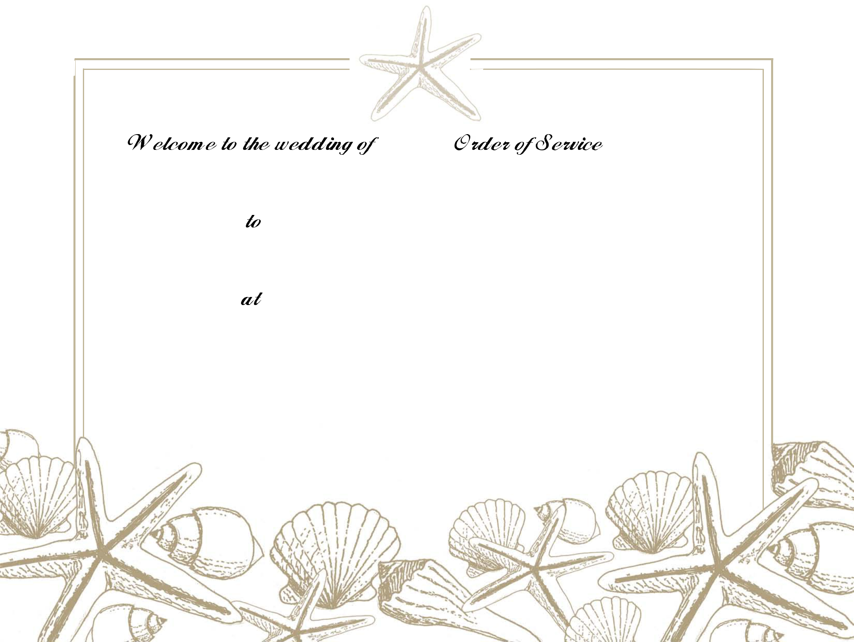*

*Event 2*

*Event 3*

*Event 4*

*Event 5*

*Event 6*

*Event 7*

*Event 8*

*Event 9*

*Event 10*