**My After-School Routine**

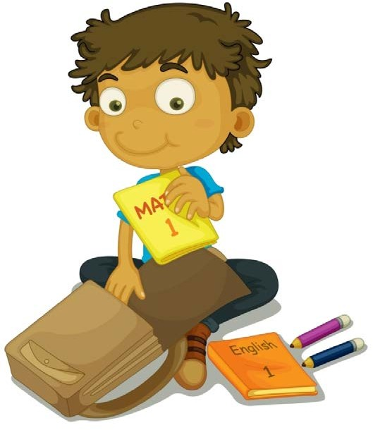

# Hang Up Coat

**Empty Backpack**

Look at my assignments for the day

Make sure I have everything I need for homework

Give Mom or Dad any parent papers

Clean out lunch box

# Have a Snack

Wash my hands first

Tell Mom and Dad about my day

# Relax and Unwind. I can…

Read a book

Go outside and play

Play a game

Invite a friend over (ask Mom or Dad first)

# Do My Homework

Double check my work

Pack my backpack for tomorrow

# Dinner and Chores

Help set/clear the table

Take out the trash

Other:

# TV or Computer Time

Stick to the time limits